# Administration Guide

## Customer Portal Solution for Microsoft Dynamics® CRM 2011

Use this guide to learn about the features and functionality in the Customer Portal solution for Microsoft Dynamics CRM 2011. This guide will cover all the capabilities that are included with the solution and the configuration options.

* Content Management Capabilities
* Portal Administration
* Features

## Content Management Capabilities

This section covers all the content management functionality available in the Customer Portal solution for Microsoft Dynamics CRM and the ways that you can manage the look and feel of your web portal.

### Content Editing

A key feature in the Customer Portal solution for Microsoft Dynamics CRM is the ability to manage portal content quickly and easily. All the content is stored in your Microsoft Dynamics CRM system. The web portal reads from the system to render the portal pages. You can grant permissions for users to edit the content using client-side editing tools.

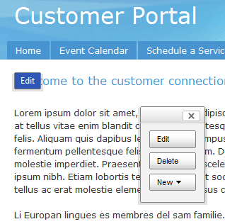

This means that the text on pages, navigation structure, colors and styles can all be done from the portal itself without the need for HTML coding or the use of other, more cumbersome web management tools.

The HTML editing capability is still preserved if you need that finer level of control on the content, but the objective is to allow a business user to be able to manage their website content quickly and easily.

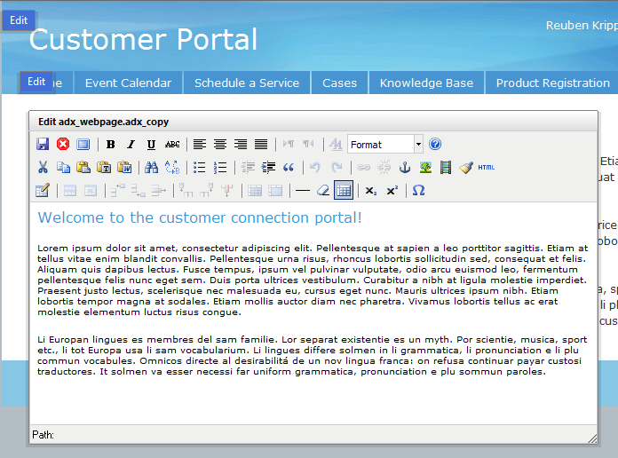

The editing process is simple – wherever there is an edit pop-up tag, the user can click and edit that content, whether that is a title, string or full blocks of text the editing is as simple as formatting a Microsoft Word document.

The user can also add new pages and files to the website, as well as edit the navigation structure of the website.

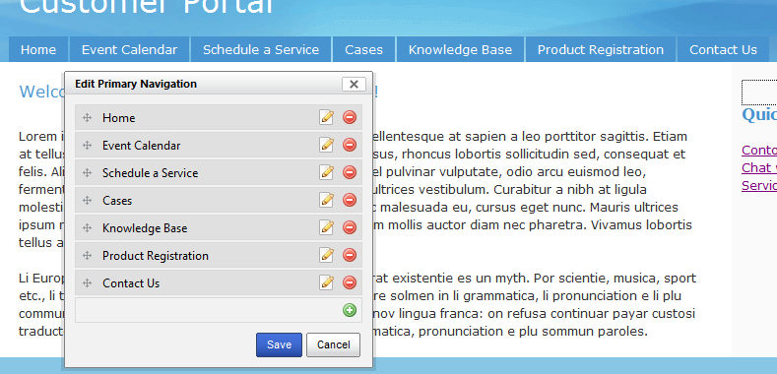

To add new web pages or web files, you can use the floating toolbar that includes three buttons: **Edit**, **Delete** and **New**. To create new web pages in your website, navigate to the website to which you want to add a child page, click on the **New** button, and then click **Child page**.

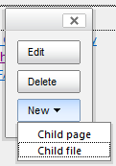

Give the page a **Name** and **Partial URL**. For example if you wanted a page for Frequently Asked Questions (FAQs) you would set the name to “**FAQs**” and the Partial URL to “**faqs**”. This would mean that the URL for the page would be: **“your portal base URL”/faqs**.

The content management engine also allows you to utilize page templates which provide a means to maintain a consistent look and feel throughout your entire website. Page templates are your own page templates built using ASP.NET pages, master pages, cascading style sheets (CSS), user controls, and server controls. Several page templates are included in the Customer Portal solution for Microsoft Dynamics CRM.

Once you have set the necessary **Name**, **Partial URL** and **Page Template** values, click the **Save** button to add the new page to the website.

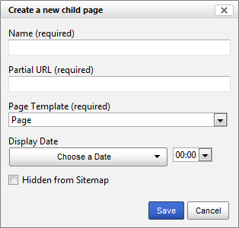

To list this new page in the website navigation, click the pop-up edit tag next to the primary navigation tabs. You will be presented to with a new pop-up window that allows you to edit, remove or add new navigation links. Click on the  button to add a new entry to the navigation. Click on the  button to remove a page from the navigation.

**Note**: Removing a page from the navigation does not delete the webpage from the website.

Provide the name and select the page you just created, you can re-order the navigation structure by clicking the  button, and then dragging the entry up or down the list.

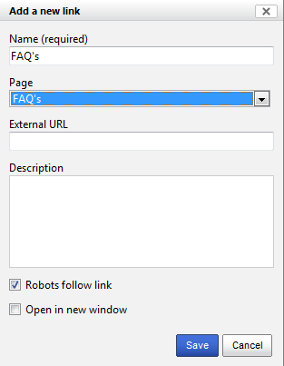 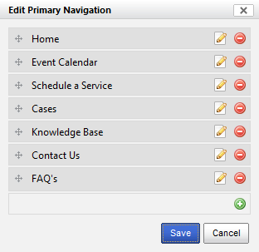

When you click the **Save** button, the page will refresh with the new navigation structure in place.

You can also add files to the website. These files can be graphics that you want to use in the site or documents that you want to make available for your web portal customers to download.

All of this content is stored in Microsoft Dynamics CRM, which you can access and review by opening the relevant website you are managing.

### Site Settings

There are many site settings that you can modify in Microsoft Dynamics CRM without having to modify any code or cascading style sheets (CSS).

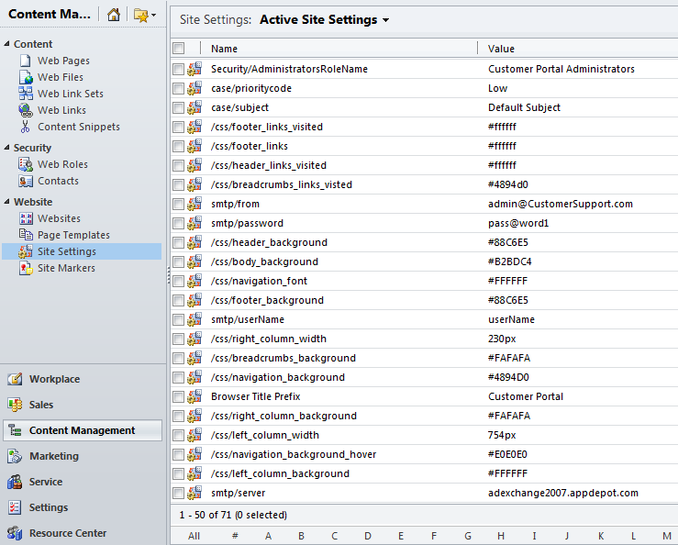

There are various settings for colors, fonts, column widths, strings, and SMTP settings. If you make a change, you will need to invalidate the website cache. For more details on this, please see the section in this document titled “Cache Management.”

### Web Roles

Web Roles are used to govern which contacts in the Microsoft Dynamics CRM system have the permissions to use the client-side editing capabilities. By default, no one has the permission to edit the portal using the client-side tools. To give users permissions to edit the portal, open their contact record in Microsoft Dynamics CRM, and then add a Web Role record.

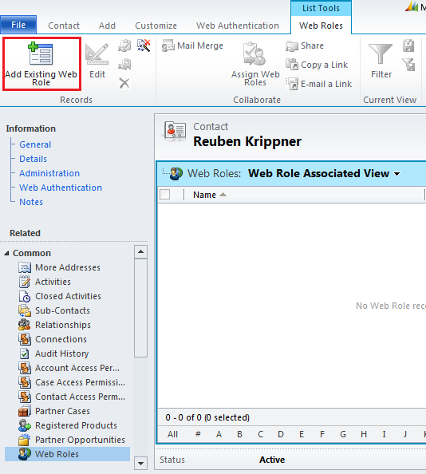

Select the relevant web role – in this case, it is Customer Portal Administrators.

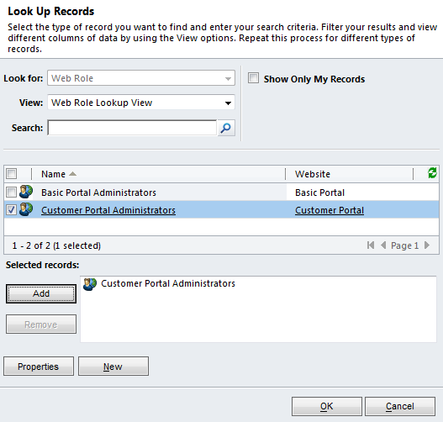

Click OK, and the web role is applied.

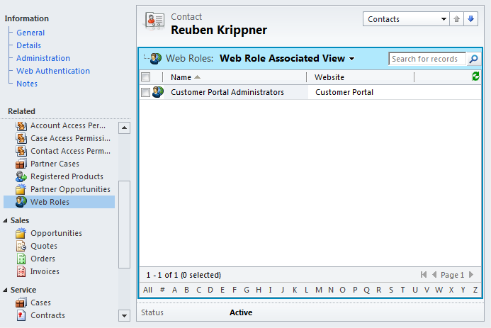

The next time that the contact logs into the portal, he or she will have the ability to edit the portal content in real time. Similarly, if you want to revoke edit capabilties for a web portal customer, then delete the web role record that is linked to the customer’s contact record.

### Cache Management

Websites that have been developed using Advanced Developer Extensions for Microsoft Dynamics CRM make heavy use of caching. As a result, changes made to Microsoft Dynamics CRM entities within the Web application or in Microsoft Dynamics CRM for Outlook may not immediately show up on the website. To resolve this, you can set up cache invalidation to happen automatically with the use of the Web Notification Plugin and a **Web Notification URL**.

First verify that the web notification plugins are enabled for the solution. The Customer Portal solution can be found in the **Settings** menu, under solutions. From the solution window, select Sdk Message Processing to see the installed plugins.

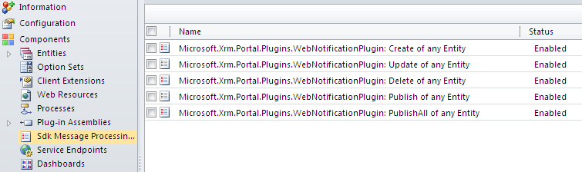

Next create a new **Web Notification URL** (from the Settings menu) that goes to the cache invalidation handler of your website. The URL to your cache invalidation will be http(s)://your-website-domain/**Cache.axd**.

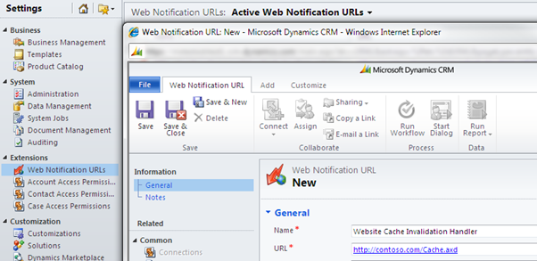

Now, anytime entities are created, updated or deleted, your website’s cache invalidation handler will be notified and it will invalidate the necessary cache depending on what has changed.

Cache can also be invalidated manually by recycling the application pool, rebuilding the Website in Visual Studio, saving the web.config file, or by adding a browser toolbar button that will hit the cache-invalidation handler. This will refresh the website with the Microsoft Dynamics CRM changes.

The toolbar button is a link that is added to your bookmarks with a script for its URL.

In Internet Explorer, use this script:

javascript:var sURL=document.location.protocol + '//' +document.location.host;var oHttp=new ActiveXObject("Msxml2.XMLHTTP.6.0"); oHttp.Open('GET',sURL+'/Cache.axd?Message=InvalidateAll&d=' + (new Date()).valueOf(),false);oHttp.Send();window.location.reload(true);

In Firefox, use this script:

javascript:var%20url%20=%20document.location.protocol%20+%20'//'%20+%20document.location.host%20+%20'/Cache.axd?Message=InvalidateAll&d='%20+%20(new%20Date()).valueOf();%20var%20req%20=%20new%20XMLHttpRequest();%20req.open('GET',%20url,%20false);%20req.send(null);window.location.reload(true);

To use this script, you have to navigate to the website that you want to refresh, and then click on your toolbar button that you set up above. The cache for that website will be invalidated and you should see the changes you made.

## Portal Administration

### Inviting Customers to Register on the Portal

In order for a web customer to have access to the eService functionality on the customer portal, the customer must be invited to register. This process involves four discrete steps:

1. Record their contact information. E-mail address, secret question and answer in Microsoft Dynamics CRM.

Web portal customers are represented by contact records in Microsoft Dynamics CRM. To invite a customer to the portal, the person must have an active contact record in Microsoft Dynamics CRM that includes an e-mail address. Additionally, you will have to contact the individual to obtain a secret question and answer pair (e.g. what was your first dog’s name? answer = fido). This information is stored in Microsoft Dynamics CRM in the contact record (on the **Web Authentication** tab) and is used as part of the invitation process to make sure that the person who registers for the portal is indeed the individual you will be sharing potentially sensitive information with.

1. Generate the invitation code. On the contact form in Microsoft Dynamics CRM, click the **Create Invitation Code** button which is on the **Web Authentication** tab.

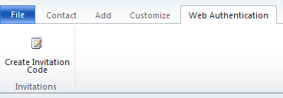

It will populate key fields in the **Web Authentication** section of the contact record – this sets an invitation code and an invitation expiry date/time.

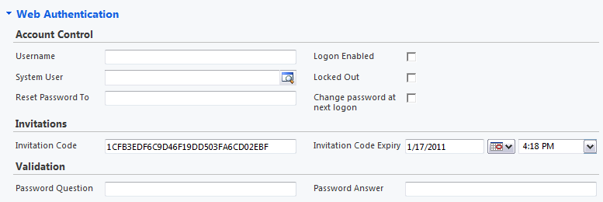

Once this is done, save the contact record.

1. You will now send the invitee an e-mail message that includes a link to the registration page in your portal. This is automated for you by running a workflow. You can run the workflow by clicking the **Run Workflow** button on the contact record.

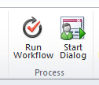

Select the **MSA–Customer Portal: Customer portal sign-up invitation** workflow from the list, and click OK.

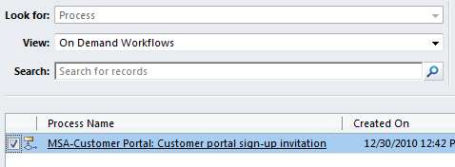

This will send an e-mail message with the registration link for that web portal customer.

**Note**: You should edit the workflow to ensure that the e-mail content contains the text you want to send and that the URL will send your customers to the right web portal for sign-up.

1. The web portal customer receives the e-mail message and clicks on the link. The customer is asked to sign in with his or her Windows Live ID. The customer is further challenged with the secret question that he or she provided at the beginning of the sign-up process. If the answer matches the answer recorded in Microsoft Dynamics CRM then the person is granted access to the portal and the customer can utilize the functionality outlined in this document. If the answer does not match then the customer is prevented from gaining access to any data from Microsoft Dynamics CRM and the customer cannot use the bulk of the functionality in the portal.

### Membership Management

Web portal customers can be granted a variety of permissions related to what they can do on the portal with respect to Microsoft Dynamics CRM data. Specifically, there are three main access rights for the portal:

* **Account Access**. If a contact is linked to an account in Microsoft Dynamics CRM then you can grant the web portal customer the ability to edit account information on behalf of his or her company. For example, Allison Brown is in the Microsoft Dynamics CRM system as a contact and she has been invited to be a web portal customer. Allison’s parent customer is Contoso for which there is an account record in Microsoft Dynamics CRM. If you grant account access to Allison on the portal, she will be able to view and modify her Microsoft Dynamics CRM contact information, but also the name, address and contact information for the account Contoso.  
  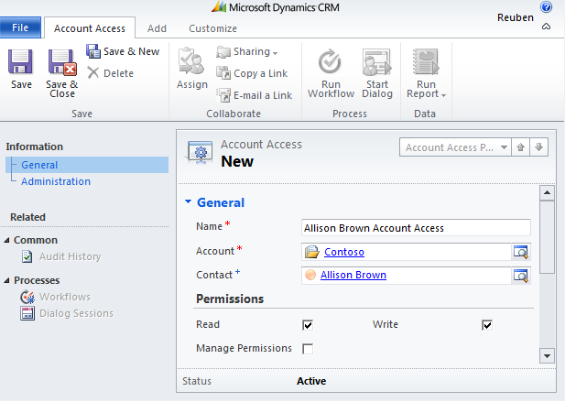

In this example, Allison Brown has the ability to read and write account profile information within the customer portal. Her profile page will look like this:  
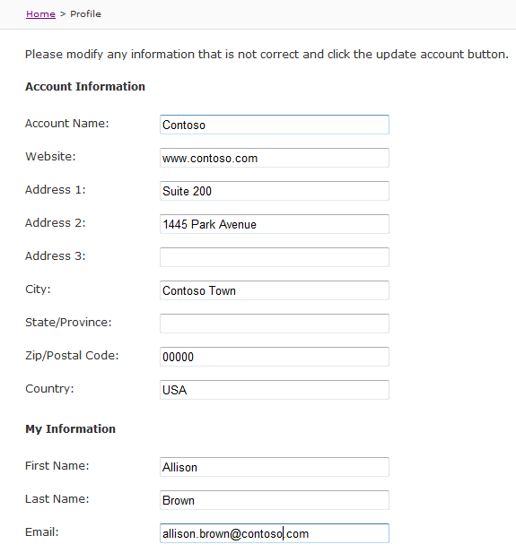

* **Contact Access**. Similarly, you can grant permissions for a web portal customer to be able to update his or her own profile information such as name, phone, e-mail address, address etc.
* **Case Access**. The third primary permission mechanism in the customer portal is to grant the ability for a web portal customer to create, read, update or delete Microsoft Dynamics CRM case information using the portal. You can also grant them a scope of **Self** or **Account**. In our example of Allison Brown from Contoso, a scope of **Self** means that Allison can only create/read/update/delete cases that are directly linked to her account. A scope of **Account** means that Allison could create/read/update/delete all of her cases and also all other cases linked to her company, Contoso.

### Site Settings

The Customer Portal solution for Microsoft Dynamics CRM provides a number of configurable settings that are updated in directly in the Microsoft Dynamics CRM system and modify the behaviour and/or look and feel of the portal.

Here is a list of the key site settings you should be aware of:

|  |  |
| --- | --- |
| Setting Name | Description |
| /css/* | All the settings with the prefix /css/ relate to various color, font and column widths throughout your portal. Any color setting uses Hex values to set the specific color for that portal component, e.g. /css/header_background sets the background color of the header region of the portal. Hex values are written as 3 double digit numbers, starting with a # sign.  Please remember to invalidate your portal cache when you have made changes to these settings to make sure the portal code uses the new value(s). |
| case/prioritycode | This sets the default priority code for cases that have been registered through the customer portal. This is a string value which must match the text of the relevant value for case priority, typically this will be High, Normal and Low. |
| case/subject | This sets the default subject for cases that have been registered through the customer portal. This is a string value that must match the text of the relevant subject value for the case subject. Typically this will be Default Subject. |
| smtp/* | The SMTP settings are used by the portal to send KB article e-mail messages. There are 4 settings that need to be provided:   * **from**: the e-mail address that is displayed in the e-mail message that is sent to customers. * **server**: the SMTP server name. * **userName**: the user name of the account required to send an e-mail message on behalf of the SMTP server. * **password**: the relevant password of the SMTP account. |

## Features

The Customer Portal solution for Microsoft Dynamics CRM includes the following web portal features:

* Contact Us (lead capture)
* Event Management
* eService

### Contact Us (lead capture)

Typically one of the basic requirements of any business web portal is to provide lead-capture capabilities – customers and prospects that come to your web portal register so that they can get more information about your products or services. The Customer Portal solution for Microsoft Dynamics CRM includes a Contact Us form to enable customers and prospects to enter their contact information.

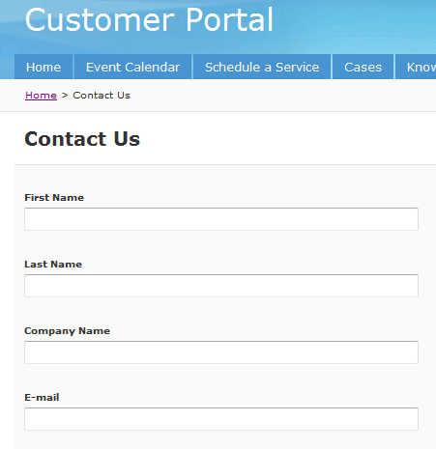 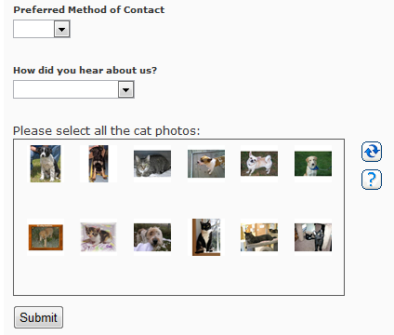

The customer fills in the information and then clicks the **Submit** button.

To provide a deterrent against spam and denial-of-service-attacks, the web page has employed the novel Completely Automated Public Turing test to tell Computers and Humans Apart (CAPTCHA) mechanism. This provides some resistance against anonymous, malicious attacks on your site. CAPTCHA asks the user to identify which pictures are cats and then allows the user to submit the information through the portal where it is then written to Microsoft Dynamics CRM as a **lead** record.

**Note:** The CAPTCHA mechanism is purely a sample. You are encouraged to use a more robust CAPTCHA tool for your production web portal.

### Event Management

The Customer Portal solution for Microsoft Dynamics CRM provides an event management module that is built on top of the campaign management functionality in Microsoft Dynamics CRM. It allows organizations to plan, manage and review events. Users set up campaigns (events), marketing lists (invitee lists) and track campaign responses (registrations/cancellations). There are additional customizations provided to facilitate event management-specific processes. The data model is very rich and allows for tracking of event venues and sessions as well as internal and external team members, event packages and group allocations. This data model is not significantly leveraged by the web portal but is provided to give you maximum flexibility with your custom requirements.

The Customer Portal solution for Microsoft Dynamics CRM also provides an event calendar and web registration management for events.

#### Setting up an event:

An event is a specific type of campaign in Microsoft Dynamics CRM.

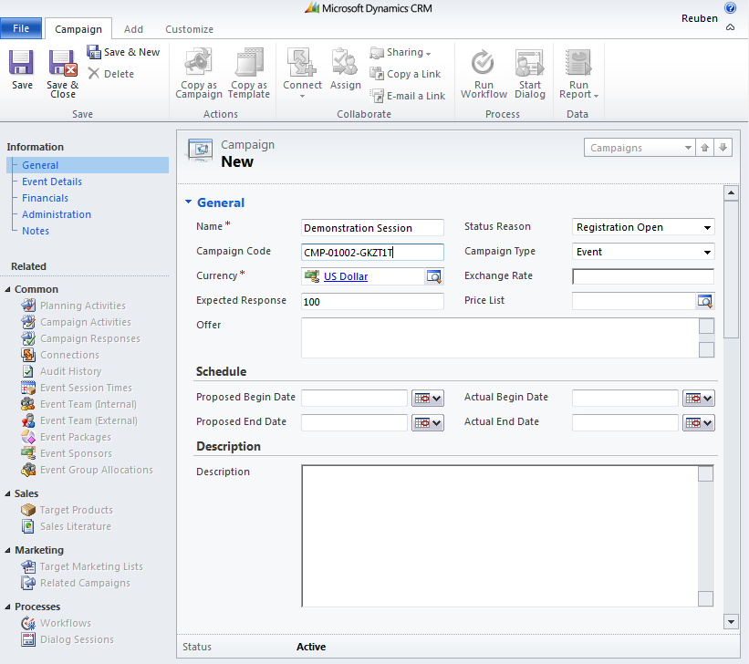

The information on the General Tab is largely ignored by the portal except for two key fields:

* The **Campaign Type** must be set to **Event** for the portal to display this event in the calendar.
* The **Status Reason** also must be set to **Registration Open**, **Waitlist Only**, or **Sold Out** – otherwise it will not be displayed in the portal’s event calendar.

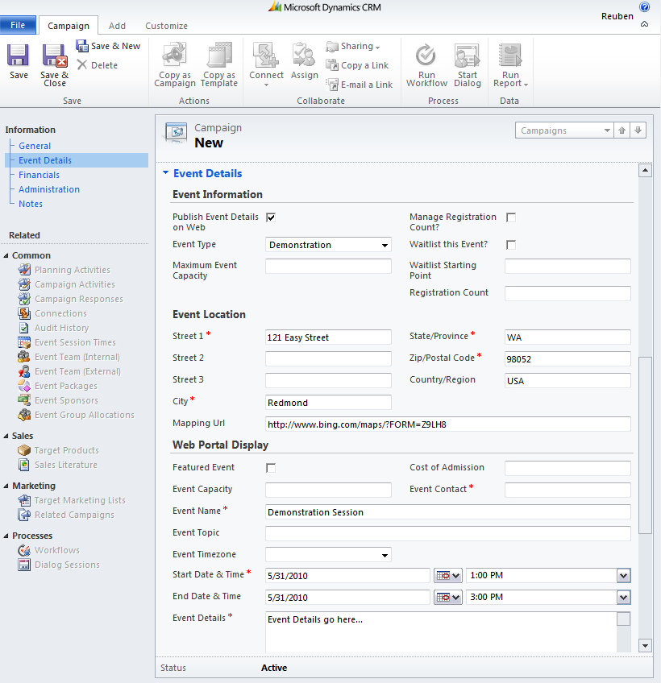

The information on the **Event Details** tab displays key event information on the portal. An event is displayed on the portal only if the **Publish Event Details on Web** check box is selected. Additionally, if you want the event to be more prominently displayed in the Featured Events section of the event calendar, select the **Featured Event** check box.

The user experience for your customers is straightforward. The web portal customer goes to your portal (they don’t have to be logged in to register for an event) and clicks the **Event Calendar** link in the main navigation.

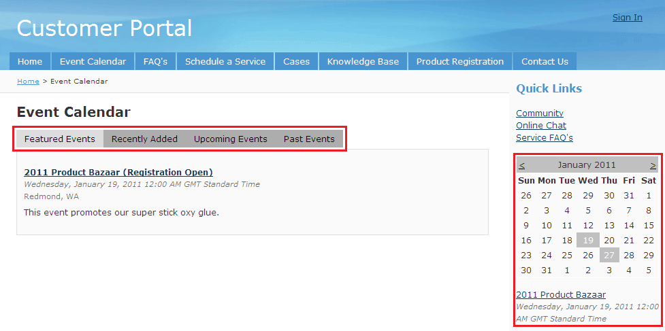

The web portal customer can then navigate between different filtered views of events: **Featured**, **Recently** **Added**, **Upcoming Events**, and **Past Events**. A calendar control allows customers to filter events by month – if there is an event(s) on a specific date, it will be highlighted in the calendar on the right side of the page. Once a customer has decided to register for an event, she or he can click a link to go to the event details page.

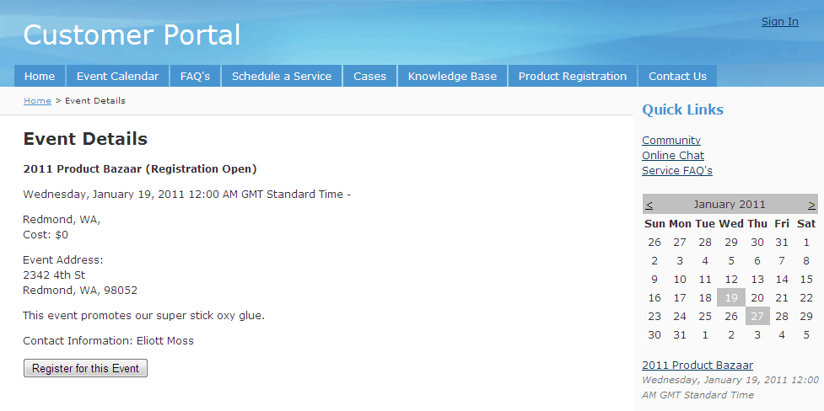

The event details page displays all relevant event information from the campaign record in Microsoft Dynamics CRM. If the status of the event in the campaign record is set to **Registration Open** or **Waitlist Only** then the web portal customer can enter and submit their contact details. The submission automatically creates a campaign response record in Microsoft Dynamics CRM that is linked to the event campaign record.

You can configure workflows that will automatically send an e-mail message to the web portal customer acknowledging their registration. Define a workflow that will send an e-mail message to the web portal customer’s e-mail address upon creation of a campaign response. If the campaign response is related to a campaign of type **Event** and the **Response Code** is **Registered**, **Registration Cancelled** or **Waitlist**.

If the status of the campaign is set to **Sold Out**, then the event details page will display all relevant event information but the register button is not displayed.

### eService

The Customer Portal solution for Microsoft Dynamics CRM provides an eService module that allows web portal customers to access, modify, and create specific records that relate to their service relationship with your organization. Essentially, the purpose of the eService module is to provide self-service capabilities for your customers.

#### Profile Management

From the **Manage Account** link (found at the top right when logged in), a web portal customer can update any of their profile information directly from the portal site. Their profile information may include:

* **Contact Profile**. This represents the logged in user, and contains information specific to the user, such as their name, e-mail address, address and contact information.
* **Account Profile**. This represents the company that the web portal customer is associated with. Typically this will include the name of the company, the general contact information for the company, and so on (access to the account record is not available to all web portal customers – see the section titled “Membership Management” in this document).

#### Product Registration

It is common for an organization to have their customers register purchased products. This allows the organization to contact customers with important information regarding the product after the purchase. The Customer Portal solution for Microsoft Dynamics CRM allows web portal customers to register products online. Not only is this convenient for customers, the registration information goes directly into the Microsoft Dynamics CRM eliminating the need for data entry or transfer.

To register a product, the web portal customer must first be logged in. The customer fills in the product registration form and clicks the **Register** button.

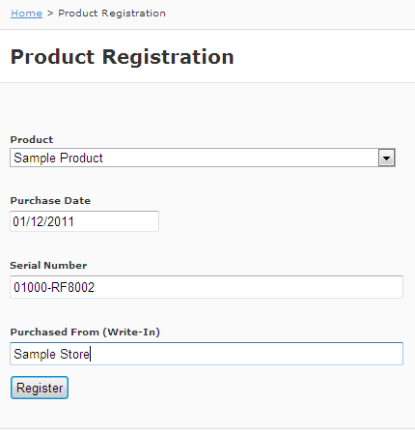

From the **Service** menu, the product registration information can be found as a **Registered Product** record in the Microsoft Dynamics CRM.

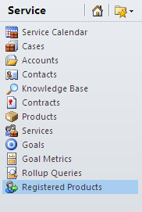

#### Case Management: eService module

The use of cases will vary depending on your type of organization. Typically, cases are used to track and resolve different types of customer issues. The eService module in the Customer Portal solution for Microsoft Dynamics CRM allows web portal customers to create cases themselves, bypassing the need to speak directly with people in your organization.

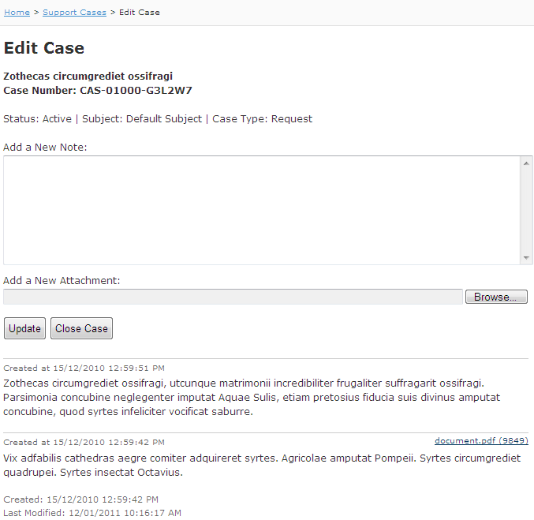

##### Update cases

The web portal customer is also able to review and update any of the information originally provided in the case record, whether the case is open or closed.

Web portal customers can easily attach documents to case records. All they have to do is browse to the document they want to attach, and then click the **Update** button.

##### Add case notes

Case notes are brief items of information added to a case record. A case note can be viewed by all users who have access to the case record. Web portal customers can use notes to submit comments or ideas, or to share information with the support team that is working on their case.

Web portal customers can easily add case notes, and then click the **Update** button to include that information in the case record.

**Note:** Any case notes that are entered by a Microsoft Dynamics CRM user directly through the Microsoft Dynamics CRM record will only be displayed to a web portal customer if the **\*WEB\*** keyword is somewhere in the case note body.

##### Close cases

A web portal customer can close a case directly from the portal. When editing a case, the customer can click the **Close Case** button. The system will ask the customer for a satisfaction rating and a closing resolution comment. The customer can then click the **Close Case** button again. This action will automatically close any open activities that are linked to the case record in Microsoft Dynamics CRM.

A web portal customer also has the ability to re-open a closed case if they feel that his or her issue has not been dealt with properly.

#### Service Scheduling

Microsoft Dynamics CRM includes an appointment-based service scheduling capability that enables you to define your services, resources, work schedules, and service locations. This feature also provides you with a centralized, consolidated view of your professional service workers' calendars and schedules. The eService module within the Customer Portal solution for Microsoft Dynamics CRM exposes this functionality to a web portal customer which empowers the customer to book and manage service appointments with your organization.

The portal experience is very simple for the web portal customer. The customer starts by selecting the specific service he or she wants to schedule. Next, the customer selects a date/time range and a time zone to receive the specific service. Finally, the customer clicks the **Find Available Times** button.

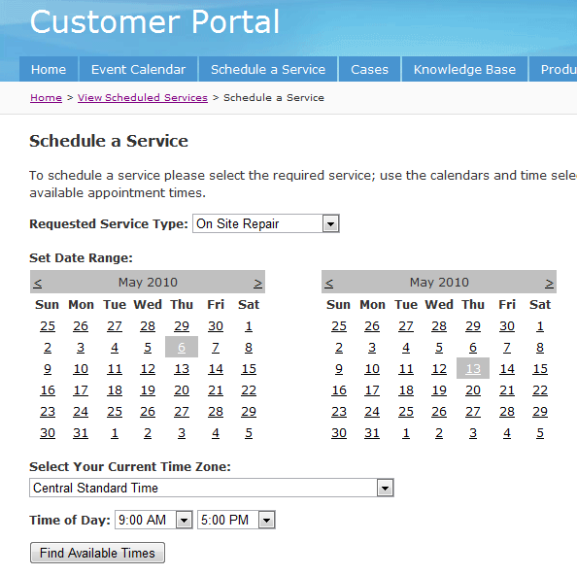

The eService module will then query the Microsoft Dynamics CRM calendar and return a list of available times where resources are available to deliver the selected service.

The web portal customer then selects a one of the listed times and clicks the **Schedule Selected Service** button. A service activity record is created in Microsoft Dynamics CRM. The customer can also add the scheduled service to their calendar client, such as Outlook, by clicking the **Add Service to Calendar** button.

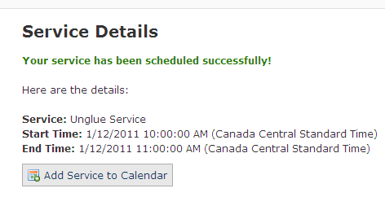

Web portal customers also have the ability to list the service appointments that they have scheduled. They can also cancel specific appointments, as necessary.

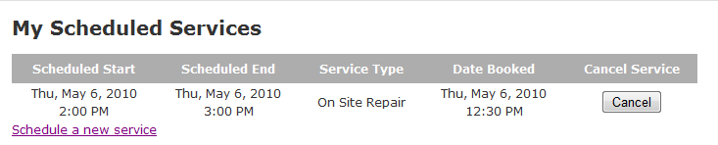

**Note**: The web portal will only provide a list of defined services from Microsoft Dynamics CRM where the keyword **\*WEB\*** is in the title or description of the service record in Microsoft Dynamics CRM.

#### Search the Knowledge Base

Web portal customers are able to search and view the Microsoft Dynamics CRM Knowledge Base directly from the portal site. Knowledge Base searches return matching articles based on a full-text search of the article body, the article keywords and the article title.

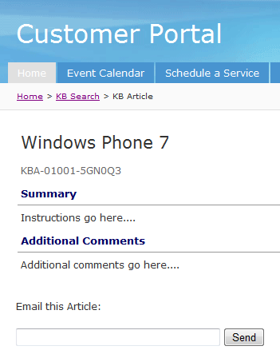

Web portal customers can e-mail specific Knowledge Base articles to themselves or others, directly from the portal site. This can be done by opening a Knowledge Base article, entering an e-mail address in the **Email this Article** field located at the bottom of the article, and then clicking **Send**. Multiple recipients can be entered in this field, their e-mail addresses must be separated by a semicolon.

**Note**: The search returns only **published** Knowledge Base articles where the **Publish to Web** check box is selected.

